Review of DC TESLA COIL Construction and Applications

Full TEXT.

Abstract—The tesla coil is an air coiled transformer which gives high frequency current and voltage output. Many alterations were done to the original design to increase the efficiency and usage of the device. This paper deals with one such alteration, which is replacing the AC supply with a DC supply and study the output of the device. With the change in the supply the circuit components were changed as well. A DC supply is given to a solid state miniature tesla coil with a slayer exciter. A series of simulations and practical tests are run to study about the nature of the output that is being received. Various applications and uses are also suggested theoretically and which are under development. This paper opens up a wide scope for future study in the area of wireless power transmission and high voltage electronics.

Index Terms—Mini tesla coil, slayer exciter, DC tesla coil, Wireless power transmission.

INTRODUCTION

Nikola Tesla developed the tesla coil in 1891, it is an air core transformer which could produce high frequency voltage and current output. The original circuit consisted of a high voltage AC supply, a spark gap, a capacitor, a primary coil linked to a secondary coil. The specialty of the secondary coil was that one end of the coil was open to air. The secondary coil’s end was liked to earth.

The working of the coil is simple, when the high voltage supply is given to the circuit, the capacitor starts to charge. As the capacitor charges to its peak value no more current can flow thus the spark gap which is in parallel with it will start to ionize the air present in between. Due to the high potential ~~immense flow of current~~ the air in between the spark gap will ionize and even though there wouldn’t be any physical connection, the air would conduct and the spark gap will fire ~~up~~. Current will be transferred through air to the other end of the circuit. Once this happens the capacitor will discharge too. This current will flow to the primary coil and a magnetic field will be produced which will be linked with secondary coil. Now when the electrons start to flow in the secondary coil towards the top they are breaking their equilibrium state. Thus they tend to fall down backwards, this causes a more positively charged region near the top load. So it pulls the electrons with more force now, due to which more number of electrons are attracted towards the top of the secondary coil each time. Once the top load gets saturated it too ionizes the air and releases a spark in the air. As the earth is the ground for the top load, we see a long spark being released by the top load. This process takes places continuously within milliseconds repeatedly causing a continuous discharge of sparks in the surroundings.

**COMMENTS**

The output of the coil varies on a lot of factors. The value of capacitance, the length of the spark gap, inductance of the coil, number of turns, top load etc. The circuit also needs to be manually tuned in order to get the best output. Tuning is matching of the resonant frequencies of the primary and the secondary side of the circuit. Though the AC tesla coil is not used everywhere, still a lot of research is going on to improve the efficiency and usage. Different uses such as X-Ray, lightning phenomenon, production of ozone and many more were developed. But recently due to many factors there has been no major breakthrough in this field. The DC tesla coil is a step forward in increasing the usability and functionality of the device.

With the introduction of the DC tesla coil, scientists are looking at making a break through with not only wireless technology but also portable wireless technology as these are non-bulky and more efficient. Ongoing research is facing the problem of tapping the high voltage output that is being emitted by the tesla coil. This paper portrays some of the results that were achieved via continuous experimentation with the developed coil. A series of experiments were carried on to test the coil and many factors were altered so as to get the highest possible output. Some of them are really interesting and open new gates for researchers all around the globe to look into the technology and help to the development of such alternative sources of power.

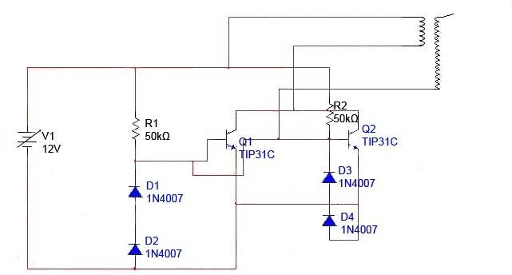

Fig. . Circuit diagram

COMPARISON

The two coils differ from the very fundamental level that is the primary circuit. Apart from the supply the spark is being replaced by a solid state device. Thus even though the characteristics of the device remains the same but the approach has been completely different. The cost, the size have drastically reduced but the output spark length have reduced to almost none.

A lot of problems faced by the AC tesla coil are being solved by using a DC tesla coil. The bulky transformer for providing smooth Ac supply is replaced by a small battery. The spark gap which would need around 3000V DC to be triggered is to be replaced by a transistor. Another thing that is eliminated is the top load. As the device does give long sparks, the top load is omitted. The major problems like bulkiness, high voltage and current, portability are solved using this model.

The major problem faced by the AC tesla coil was tuning. Tuning is the process of matching the primary coil resonance with the secondary coil resonance to get the highest possible output. The conventional tesla coils do not tune themselves. The coils have to be tuned by changing the values of other components such the capacitance or the length of the coils used. Until the two coils are not tuned the circuit will not function properly as there will be no or minimal linkage between the primary and the secondary coil. The DC tesla coil solves this problem as it auto tunes. The transistor being used is activated only when there is voltage at the gate terminal and would stop if there is no voltage. Thus it acts as a switch. The gate terminal is being controlled by the coils which will be explained later in the paper. Thus the circuit auto tunes and reduces the lengthy calculations and margin of error.

DESIGN PROCEDURE

The following are the specifications of the components used to build the tesla coil. The basic circuit diagram is shown in figure 1.

A. POWER SUPPLY

A conventional battery or a RPS can be used to power the device. A RPS is beneficial as the input voltage can be changed according to need and the application. Its also helps to keep the work zone safe as the output can rise to a very high level. Lithium polymer batteries are very efficiency batteries which provide stable DC voltage for a very long time without degrading. A RPS was used in the experiments conducted.

1) DIODES : Diodes are components which restrict the flow of current in one direction. They are semi-conductor devices. When the positive side of the supply is connected to the p side of the diode it is forward biased and thus the forbidden gap reduces and the device becomes highly conductive. When the polarity is reversed then the forbidden gap increases and thus it acts like a insulator. So this helps to maintain the flow of current in one direction in the circuit. In4007 general purpose diodes are used. These help to maintain a unidirectional current and block the reverse current from damaging the circuit. They have low forward voltage drop and gave high surge current capabilities.

2) TRANSISTORS : A transistor is a switch which three terminals. A base, emitter and collector. The collector is like a reservoir of current and the emitter is the destination. The opening and closing of the reservoir door is the base terminal. Whenever there will be voltage on the base terminal the doors will open and the charge will flow from the collector to the emitter, which is equivalent of a switch in an on state. As soon as the voltage drop equals to zero the doors will close and thus the switch will go to off state. A transistor is used to replace the spark in a conventional tesla coil. Thus the choice of transistor has to be done very carefully. Depending upon its operation as a switch, response time etc. TP31C or 2n2222 are the two good choices. In the experiment TP31C is used to its fast switching speeds and minimal leakage current. One more major factor is that the transistor has a heat sink. Due to high current values the components tend to heat up faster than usual, thus an external heat sink may also be used but it is not compulsory.

3) COILS : The coils are basically two inductors which are magnetically linked to each other. Thus insulated copper wires are used for both the primary and the secondary windings. The number of turns, the thickness of the wire, the inductance influence the output of the circuit. Thus it is very important to pay attention and do rough calculations before making the coils. For the secondary coils a wire of AWG between 2 to 5 can be chosen and the number of turns can be somewhere around 500-1000. The primary coil has to thicker and is mostly a 12AWG copper wire with 3-5 turns. A key point is that both the windings should be in the opposite direction for the circuit to work. In the DC tesla coil they do not matter as much as they do in the conventional tesla coil as the procedure of tuning the coils is not required here.

Thus the specifications of the tesla coil that is used in this experiment are as follows:

TABLE 1

WORKING

The operation of the device is quite simple to understand. The circuit is switched on by switching on the regulated power supply. The voltage is gradually increased from 0 to 12V. Thus the current starts to flow from the positive end of the battery or RPS. Now as you see the base-collector junction is reversed bias (Both the terminals are connected to the positive end) thus the junction would become reverse bias and the transistor would remain switched off. After the current is divided into the primary coil and the base terminal, it has two ways. Due to the immense resistance offered by the reverse biased diodes the current enters into the base junction and thus switching on the transistor. Now that the switch has been opened the current can freely flow from the top to the primary coil and through the collector region to the emitter terminal. The ground terminal here can be the negative terminal of the battery. As the diodes are now in the forward direction for the flowing current enters through the diode and back to the base junction. Now this is how current flows through the primary coil after the transistor has been switched on. Now the primary coil develops an electromagnetic field which is linked to the secondary coil.

The secondary coil has a huge amount of turns as compared to the primary coil. Now when the coil comes in contact to the primary coil the electrons start to flow upwards in the secondary coil. But due to state of equilibrium the electrons would want to remain in the same state. Reason for that is because the other end of the coil is open to air which means that the resistance is very high. Thus the electrons always want to travel in the least resistant path. Thus they are like a stretched rubber band. Now due to the electrons not wanting to make an upward movement a positive charge starts to develop in the top half of the secondary coil. There is an electron deficiency and thus as more amount of linkage happens between the two coils more and more positive charge is developed. Due to this phenomenon the top half of the coil tries harder to pull the electrons present in the coil. This causes sudden high flow of electrons from the bottom of the coil to the top half. As we see the secondary is connected to the base of the transistor, the electrons are pulled from there too.

Now when a lot of electrons rush towards the top load, there is an excess of electrons. This is when the top load saturates and the resistance of the air is overcomes and a spark is produced. As the electrons jump towards a positively or neutral terminal they break the air resistance and cause a bright, high volt spark. Now here the Earth acts as the ground to the open end of the secondary coil. Due to its large surface area the Earth can absorb a lot of current. Even lighting follows the same phenomenon. Not only the earth the spark would be directed at any metal object being brought near it as it would be assumed as a ground terminal because it would be more positive than the secondary coil. The length of the spark depends upon the input voltage and length of coil etc. as explained later in experimentation.

As the electrons are also sucked in from the base terminal of the transistor, this causes the flow of current into the base terminal to stop. Due to this the transistor is turned off and there is no flow from the collector to the emitter of the transistor. The field of the primary coil collapses and thus the circuit is turned off. This process takes places several times in a second. Thus a continuous stream of sparks are observed. Sometimes we observe that there is no visible spark at the end of the secondary coil. This may be case when the circuit is either not functioning properly or the coils are not tuned. Minor adjustments can be done to rectify the mistakes such as changing the resistance values or the length of the coils.

Now the testing of the device can be easily done by two methods. Number one is to visually see the sparks created by the secondary coil by brining any metal object near the open end. This will cause a small streak of lighting to the metal. The second would be brining any light bulb near the secondary coil. The field created by the secondary interacts with the gas present inside the light bulb, which ionizes the gas present inside them. This causes the electrons to excite and when they return to their normal state they emit light. Thus the light bulb will be laminated just by being brought near to the secondary coil. The lamination will depend on the distance and the output of the circuit. Many more things can be operated wirelessly as discussed later in the paper.

There can be a few reasons for the circuit to not work to full efficiency or not work at all. One of the issue can be the windings. One should make sure that the windings are in opposite directions and there should be proper insulation all through the windings. The turns made should not overlap each other as that will cause disruption in the field that is being created and thus will weaken it. The circuit should be connected properly and care should be taken to not have any loose ends as the output of the circuit is very high and may cause severe damage if care is not taken. Special instruments should be used to carefully check the voltage and current outputs as the normal meters won’t be able to detect the output.

EXPERIMENTATION

A set of experiments were carried out to determine the output of the device. Different kind of tests were done to find the maximum range, Voltage and current outputs, spark lengths etc. Different sets of values were taken and different scenarios were set up to test the system.

The first experiment was to check the output range of the device with the variation of input voltage. For this experiment, the variable voltage source is kept at a constant voltage and then the CFL light is brought near the secondary coil. As the light is brought near it starts to glow. Thus starting from zero distance it is moved farther away parallel to the ground. As the distance increases the amount of brightness decreases. Thus the distance is proportional to the output of the coil. Then after a certain distance the CFL will stop laminating. This point was noted and is the maximum range for that specific voltage input. This experiment is repeated with different set of input voltages. The results show us a direct relation between the areas of the field is directly proportional to the input voltage being fed to the circuit.

Now the same setup is used to determine the relation between the intensity of the output with relation to the input voltage. When the light is near to the Secondary windings the intensity of illumination is maximum. The out would be maximum if the light is kept at right angles to the field that has been produced by the secondary coil. Now as the light is moved away from the coil the illumination begins to drop thus hinting that the intensity of the field is reducing. When a certain distance is reached the light glows with minimum intensity before not glowing at all. Thus the output intensity would be maximum near to the open end of the coil.

There is no harm in holding the light in your hand as it will not cause any damage. The illumination is caused due to the excitation of the gas inside the filament and there no actual electricity flowing through the light. Thus there is wireless transmission of power. The next thing to measure would be the length of sparks that are being released. This experiment was carried out with sufficient safety and should be followed by everyone. A piece of metal object should be taken near to the secondary coil. This would cause a sudden path for the electrons from the top load and a discharge would appear. Now to take the readings, gradually start increasing the voltage from 0 to 12V. As the voltage is increased an increase in the length of the sparks increases. To measure the length of the sparks, slowly move the metal object away from the open end of the coil. The spark would extended to its maximum limit and won’t appear after the critical length, any measuring scale can be used to detect the length of the spark. Number of turns in the coils, input voltage both of these factors are massively responsible for the length of spark discharge.

The next experiment is the highlight of the paper. All these years the tesla coil has been only used as an instrument for mild research and entertainment means such as producing long sparks or creating recreational music. But with some advancement in the technology and research and several attempts, the tesla coils output can be used as actual power. The problem faced earlier were that there was no actual flow of electrons in the glow of the light bulb, thus the energy couldn’t be used to power actual devices. The output could only excite the gas filled filaments and light them up. Thus the output of the coil was basically useless and the coil was lost in time. But due to the modern technology some of the circuits can be used to tap in to the power of the tesla coil and convert it to actual DC voltage. This is a very easy and simple circuit which was used during the experiments. The circuit used here is very simple, more advanced and complicated circuits can be built.

For this experiment another coil with around 300 turns was built with 3 AWG on a non-conducting cylinder. Like the secondary coil of the tesla coil, one end of this coil is also kept open to air. The rest of the circuit is built on a breadboard.

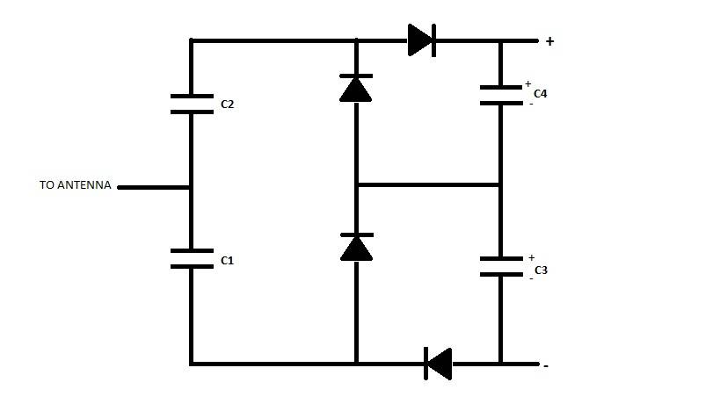

A receiver circuit is made to tap into the energy unleashed by the tesla coil. Basically this circuit converts the radio waves emitted by the secondary coil into usable DC voltage. The new coil that was made is used as an antenna which receives the signal through the open to air end. The other end of the coil is connected to the circuit board. As the electrons interact they flow downwards towards the capacitor and both the capacitors C1 and C2 start to store charge. When they are fully charged they cannot store anymore charge and thus the electrons flow outward. As the diodes are in reverse bias for the capacitor C2 all the electrons flow towards the top diode. Now the electrolytic capacitors which are connected parallel to the diodes start to store charge. Due to their polarity, one of the terminals develops a positive charge and the other end develops a negative charge. As the capacitors are fully charged, the flowing electrons flow directly to the output giving a stable output. When the circuit output is not stable or on a lower value then the capacitors discharge and maintain the level the output. Thus a constant value of out is maintained and thus a rippled DC is obtained.

The outputs of the circuits are interconnected. But only when the receiver circuit is considered the values of Capacitors change the value of DC line. As higher values of capacitors are chosen the average voltage maintained would be higher as the ability of the capacitors to hold charge increases. 1n4007 general purpose diodes work really fine for this applications but any other regular diode can also be used. But it is of utmost importance that the capacitors C1 and C2 should be ceramic capacitors of value smaller than the other two capacitors. The other two capacitors should be electrolytic capacitors with a slightly higher value than the ceramic capacitors. Another interesting fact about the receiver circuit is the circuit will give some output voltage even there is no input signal.

This is due to the radio frequencies present in the atmosphere. They can be stray frequencies or could be coming from the electronic devices from the surrounding.

Results

The maximum spark that was fired was of length 2cm from the open end of the secondary coil at 12V. The maximum range of the output was 20cm from the open end of the secondary coil. The maximum DC output recorded from the receiver circuit at 12V was 7.2V. When multiple receivers were used the output was divided among the two depending upon the distance between them and the coil.

VII. CONCLUSION AND TALKING POINTS

The experiments show that the technology shows promising results and with proper approach can be used in modern day electronics. Few applications are proposed on the basis of the outputs received.

A. This can be used as a power source is remote areas where electricity has not yet reached. A solar panel or wind turbine that can give voltage outputs up to 10V. Each home can be provided with a tesla coil in the center of the house and it can provide wireless illumination in the whole house at very low cost.

B. A larger model can be made and installed on sharing basis for a few houses. This would eliminate the cost of wires and would provide energy to multiple homes at minimal cost

C. It can be installed in homes as part of emergency backup light system. The coil can be linked to the main supply and soon as the supply is cut the emergency systems can kick in and provide energy to the critical systems. The same can be done for hospitals.

D. Wireless power in small areas such as cars, rooms etc.

E. Wireless charging spots in public are for devices like mobile phones and tablets.

F. Wireless automated home lighting system.

The suggested applications require more thorough study and modifications. A few of them have already being tested and improved. The limitations of the technology is taping of limited power and converting it into usable form. Even though the setup has been resized and made portable it still holds a problems such as interaction with electronic devices which emit radio waves for functioning and devices which contain coils.

REFERENCES

[1] C.A. Tucker, K. Warwick, and W. Holderbaum “A contribution to the wireless transmission of power,”

[2] M. Sohel Rana,A. K. Pandit ,”Design and Construction of a Tesla Coil,”.

[3] Donald G. Bruns, “ A Solidstate low voltage tesla coil”.

[4] Solid State Tesla Coil by Dr. Gary L. Johnson.

[5] William C. Brown, “The history of power transmission by radio waves.